Bio of Dr. Tom English
858-412-4993, tdenglish3@sbcglobal.net

Dr. English is the President of the TESSI Endangered Species Institute, and a Creation Care Educator for the Presbyterian Church USA. He frequently lectures on Environmental Issues to university, civic, industrial, governmental and church groups. He is ranked in the top 0.1 % of the Climate Reality Project’s speakers’ program. He is working with the Samuel Lawrence Foundation and other organizations on developing a solution to San Onofre’s High Level Nuclear Waste problem. He is co-editor of a book -Witness for the Earth: Coalescing the Religious Environmental Movement. He is Past-President of the Coalition for Clean Air, the Dallas-Fort Worth Microelectronics Society, and the San Diego Chapter of Reasons to Believe. He is on the Boards of the World Stewardship Institute, and the North County Climate Change Alliance.

He has directed major environmental programs for IBM, GE, JPL, EPA, and the Silicon Valley Manufacturing Group. He led the Manufacturing Group’s effort to voluntarily reduce toxic environmental releases by 86%. William Reilly, former Administrator of the U.S. EPA, stated that "This reduction led the entire world." His legislative accomplishments include being the architect of the California Clean Air Act, which resulted in bringing California much cleaner air while saving several billion dollars.

Dr. English advised President Carter's Office of Science and Technology Policy, the Government of Sweden, NASA, and the California Energy Commission on high level nuclear waste disposal. At the U.S. EPA, he directed an $80 million per year Energy & Environment Program. He also directed an epidemiological study of 40,000 people to determine the human health effects of air pollutants. He was Technical Director of the world’s first Regional Air Pollution Study (RAPS). He received a Presidential Award for leading the recovery program to fix the F-111 fighter/bomber after the wings fell off the aircraft.

His academic background includes a postdoctoral MS in environmental engineering, a Ph.D., and a MS in electrical engineering, and a BS in physics. He taught environmental courses at 6 universities. Dr. English presented a three-day environmental management seminar in Moscow. He and his wife, Jan, live in Carlsbad, CA. They have four adult children and seven grandchildren.

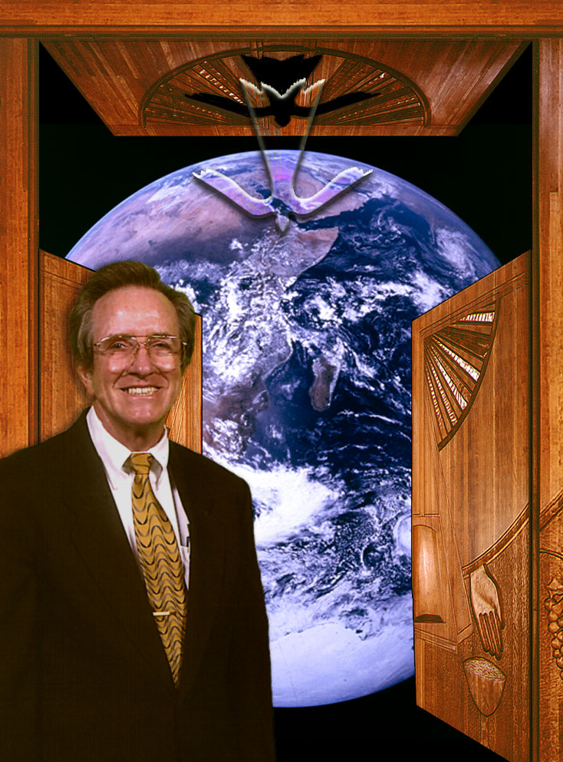

Tom founded the Solana Beach Presbyterian Church’s Creation Care Team. He co-founded the Eco-Justice Group at Mission San Luis Rey, and the North County Climate Change Alliance.

In 2012, he received the "Steward of God's Creation” award from the National Religious Coalition on Creation Care. In 2015, he received a medal from the Patriarch Bartholomew, the spiritual leader of 300 million Orthodox Christians.

He led the effort to have the Presbyterian Church’s General Assembly adopt a new policy – “On Preserving Biodiversity and Halting Mass Extinction.”

He has lectured at over one hundred universities, and has given eight White House presentations.

